M2M Communication Protocols
Application layer protocols that facilitate the transfer of messages between two devices. An important distinction between connectivity and communication protocols is that M2M connectivity protocols facilitated linking of the devices and reside on the link layer, while M2M communication protocols facilitate messaging between devices and reside on the application layer. These protocols allow devices to inter-operate with each other. They do this by standardizing the key aspects of naming, messaging, and controls.
Standardized naming means defining how each device will be referred, recognized, or found.
Standard messaging determines how each message is formatted, so that all the devices can understand it.
Standard controls enable the devices to control the flow of communication or quality of service, or to define the type of a message.
Request-Response Model
In this model, the client node sends a request to the central server node to initiate a connection, and the server responds in a predefined pattern depending on the protocol.
Publish-Subscribe Model
All the clients during or after connection establishment define what type of messages they are interested in, generally called topics or classes. Whenever a client, a publisher sends a message of a specific topic, the message is forwarded to all those clients or subscribers who have expressed interest in the topic in question.
Problems
A web connected cyber physical system inherits the problems of the current internet and most likely amplifies them, because of it's direct connection to the real world. Two of these issues are security and privacy. Security is an important differentiating factor in the choice of a protocol.
Distributed operations means that there is no central node to control operation and communication of the other nodes. Instead, communication is one to one, where the communicating nodes are on equal grounds. Some protocols might request that the data goes first to a central point, a server or broker, from which it is then distributed to the intended recipient. Being able to know who and what is on the network is as important as the ability to communicate with them. The protocol may offer means by which machines can recognize peers or associated group members in the network. Messages and payload support can be a decisive factor in selecting a protocol.
COAP - Constraint Application Protocol
COAP is a standardized request response protocol. It's creators redesign functions from HTTP taking into consideration, the target device's CoAP will be used on. That is embedded devices with limited processing power, storage, and bandwidth. It also supports publish-subscribe style communication and resource discovery. CoAP uses UDP as the transport protocol and has a dual layered structure. The transactional layer takes care of message handling between nodes, and the request response layer manages resources and transmits messages. This enables efficient congestion control and reliability over UDP.
HTTP - Hypertext Transport Protocol
HTTP, is the backbone of modern world wide web. It is the protocol for exchanging information between Internet connected nodes that communicate via hypertext, for example, your browser and web server. HTTP sets up the regulations on how nodes are going to communicate, and also specifies the content. HTTP relies on TCP as the transport protocol for packet transmission.
MQTT - Message Queuing Telemetry Transport
MQTT, was invented by IBM and RCom to collect data from remote devices to back up it's server. It was introduced in 1999 by IBM, and it was standardized in 2014. MQTT is meant for lightweight devices, which are constrained by both processing power and memory. Besides this, the protocol can transmit data over low bandwidth and reliable connection. The static header size of MQTT is just 2 bytes.
It is an open-source free to use standard protocol. MQTT relies on TCP as the transport protocol. MQTT is inherently a published subscribe protocol. Clients connect to a server to send and receive messages on the channels of their interest. The server is called a broker, senders are publishers, and receivers are subscribers.
XMPP - Extensible Messaging and Presence Protocol
XMPP was originally a text-based messaging protocol for messaging between devices over a network using the XML document format. XMPP is being explored for Internet of Things by the XMPP standards foundations for access control and sensor data. It's strong point is it's very familiar device at server naming approach. Besides this, it provides end to end security, provisioning, and publish subscribe style communication. It is slow, but secure and uses TCP as the transport protocol.
DDS - The Data Distribution Service
DDS, is a standardized, publish-subscribe protocol that enables devices to communicate in near real-time. DDS has its own interoperability protocol called Wire, which enables different implementations of DDS to communicate and interoperate. In a DDS environment, anyone can be a publisher, subscriber or both. It also offers an extensive quality of service support allowing efficient and versatile implementations of quality of service policies. It can use either TCP or UDP as a transport protocol.
AMQP - The Advanced Message Queueing Protocol
AMQP has its roots in the financial industry. It relies on queues between senders and receivers for reliability and in delivery of messages. AMQP uses TCP as the transport protocol. It allows a server to initiate a connection with the client. Unlike HTTP in which the connection has to be initiated by a client. AMQP is flexible. It offers peer-to-peer, client-to-broker and broker-to-broker communication.
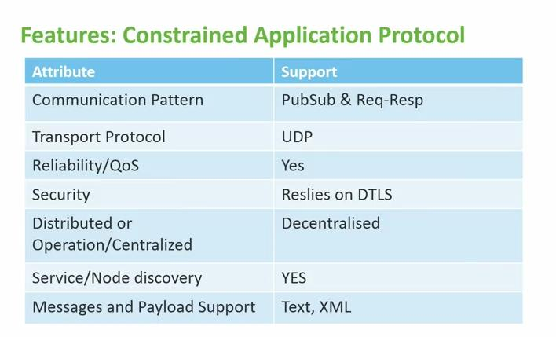 | 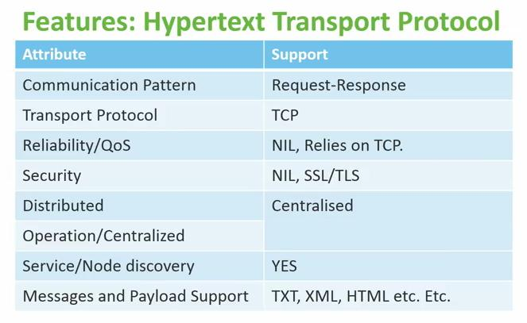
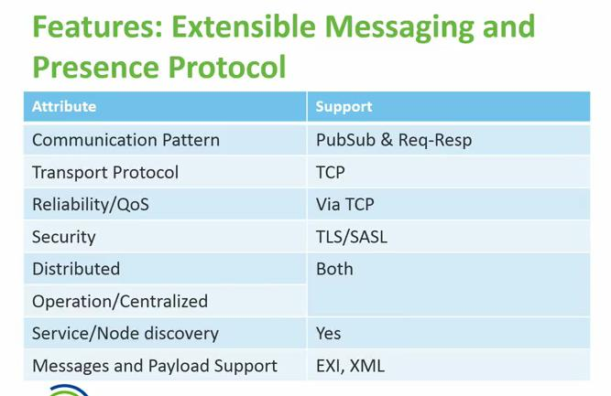 | 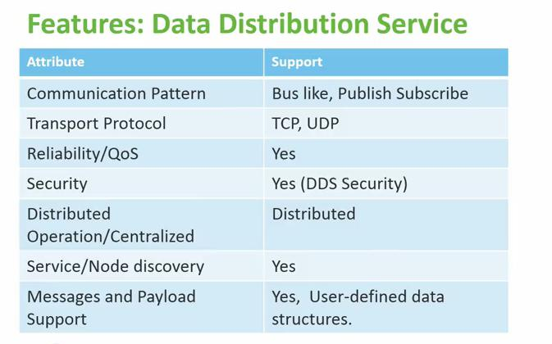
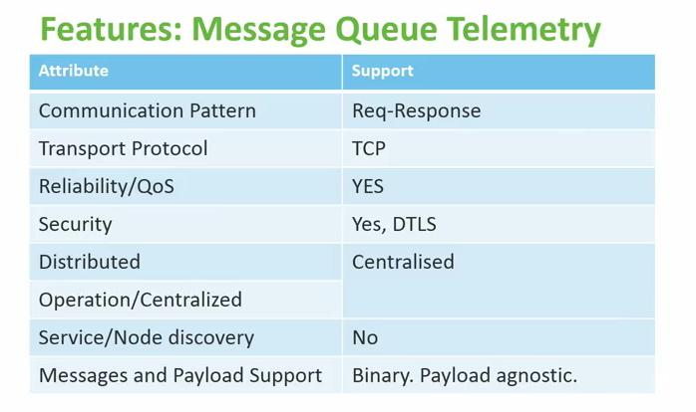 | 